
CS 255 System Design Document Template

UML Diagrams

UML Use Case Diagram

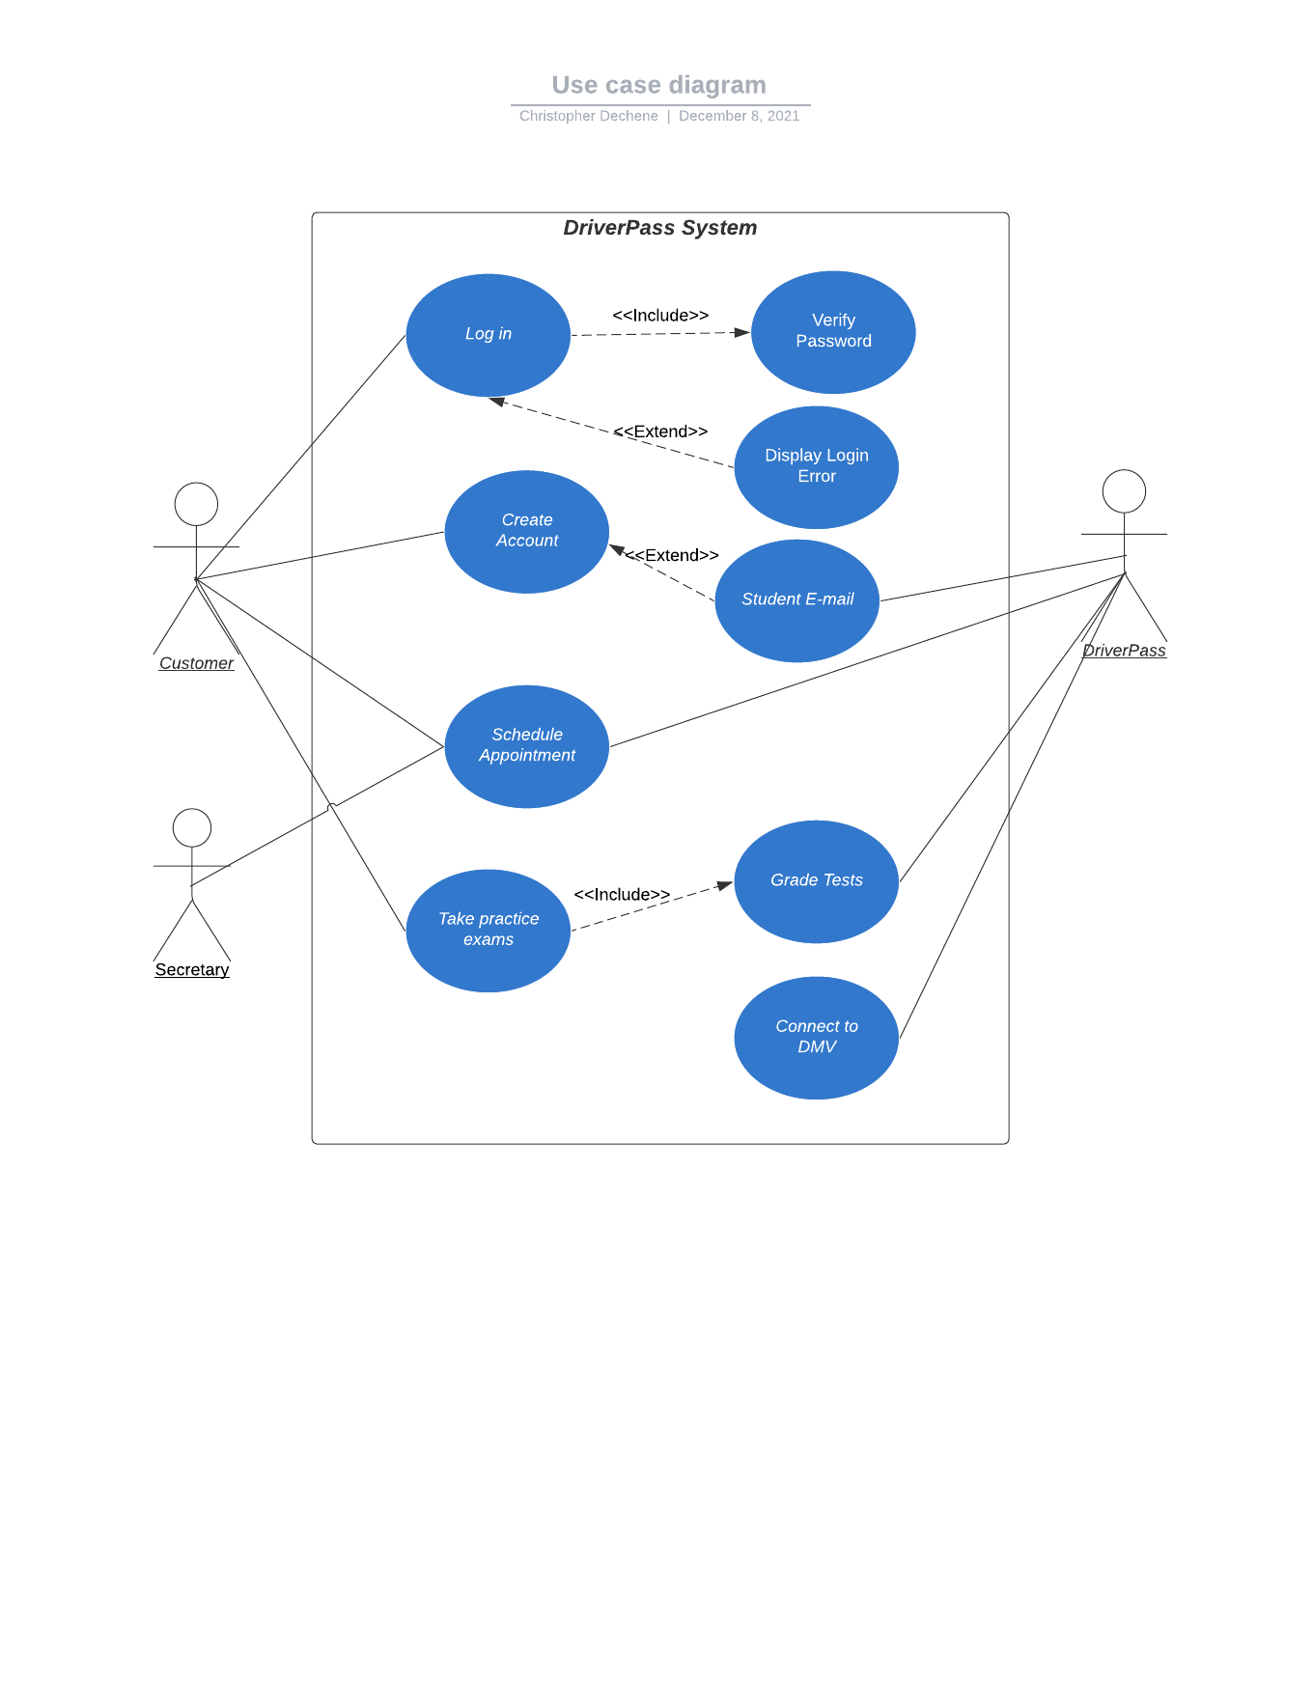

UML Activity Diagrams

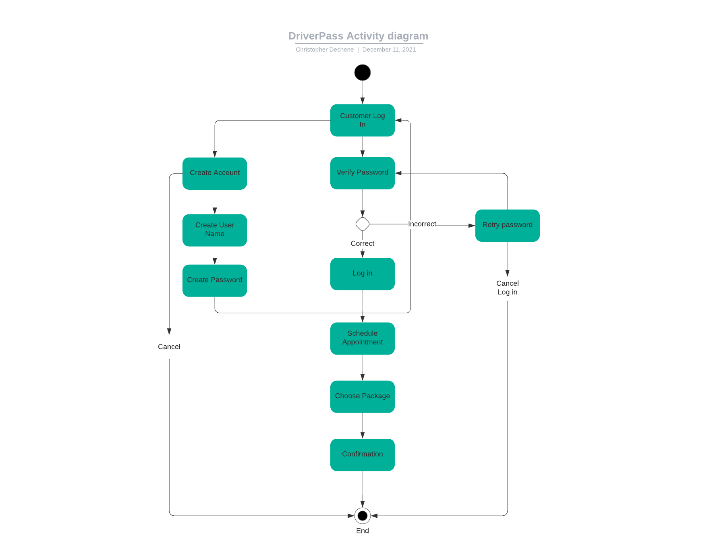

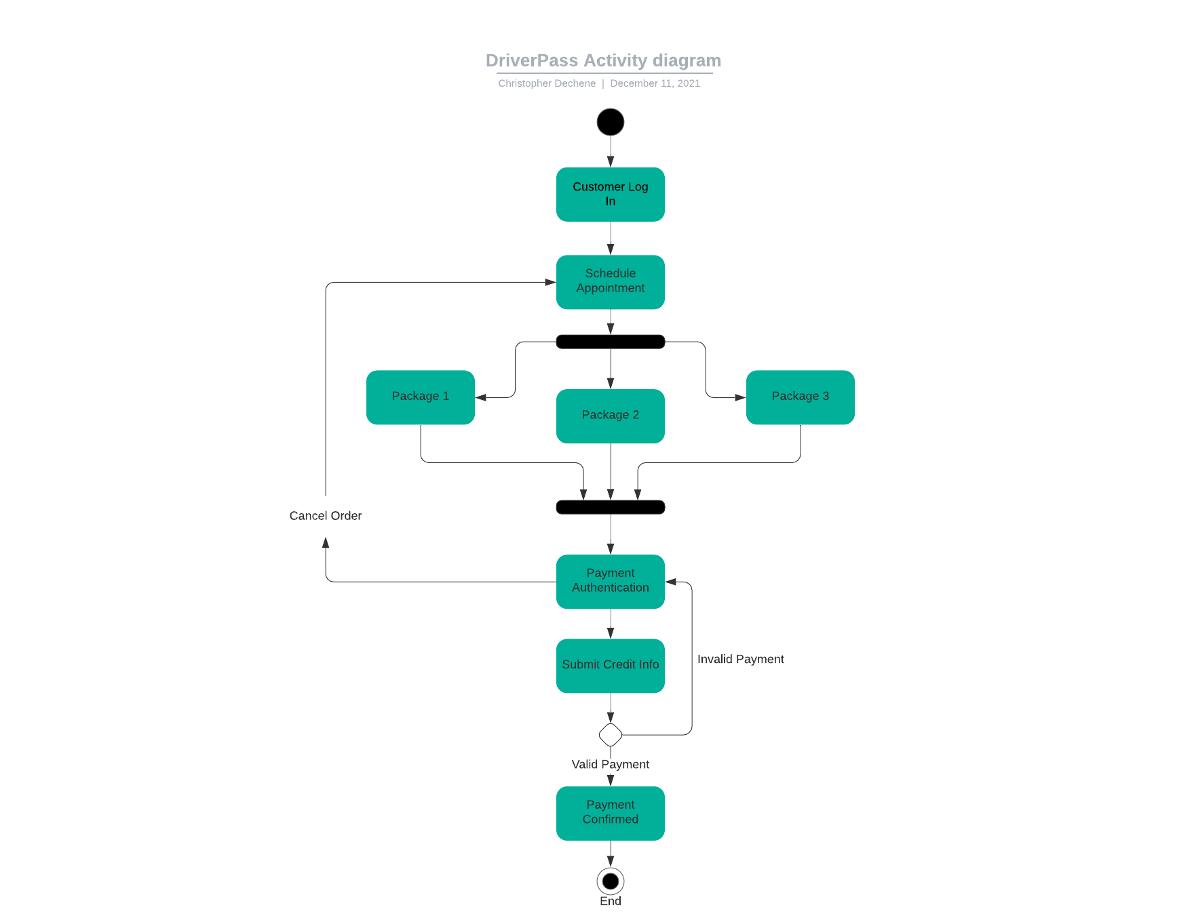

UML Sequence Diagram
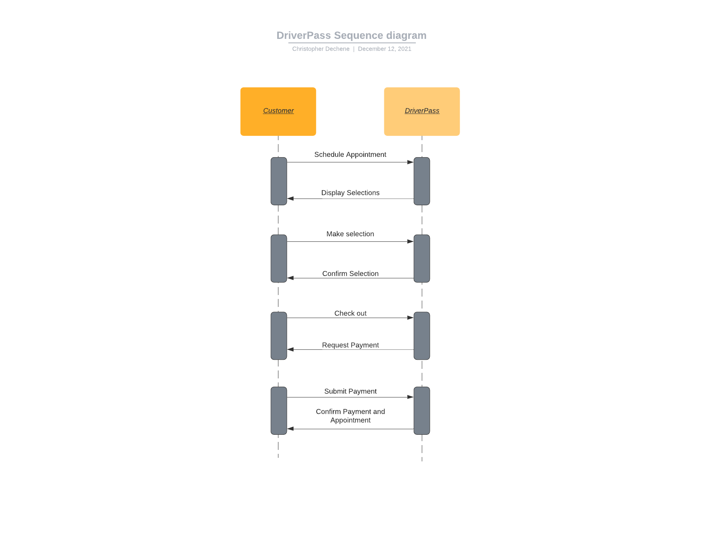

UML Class Diagram

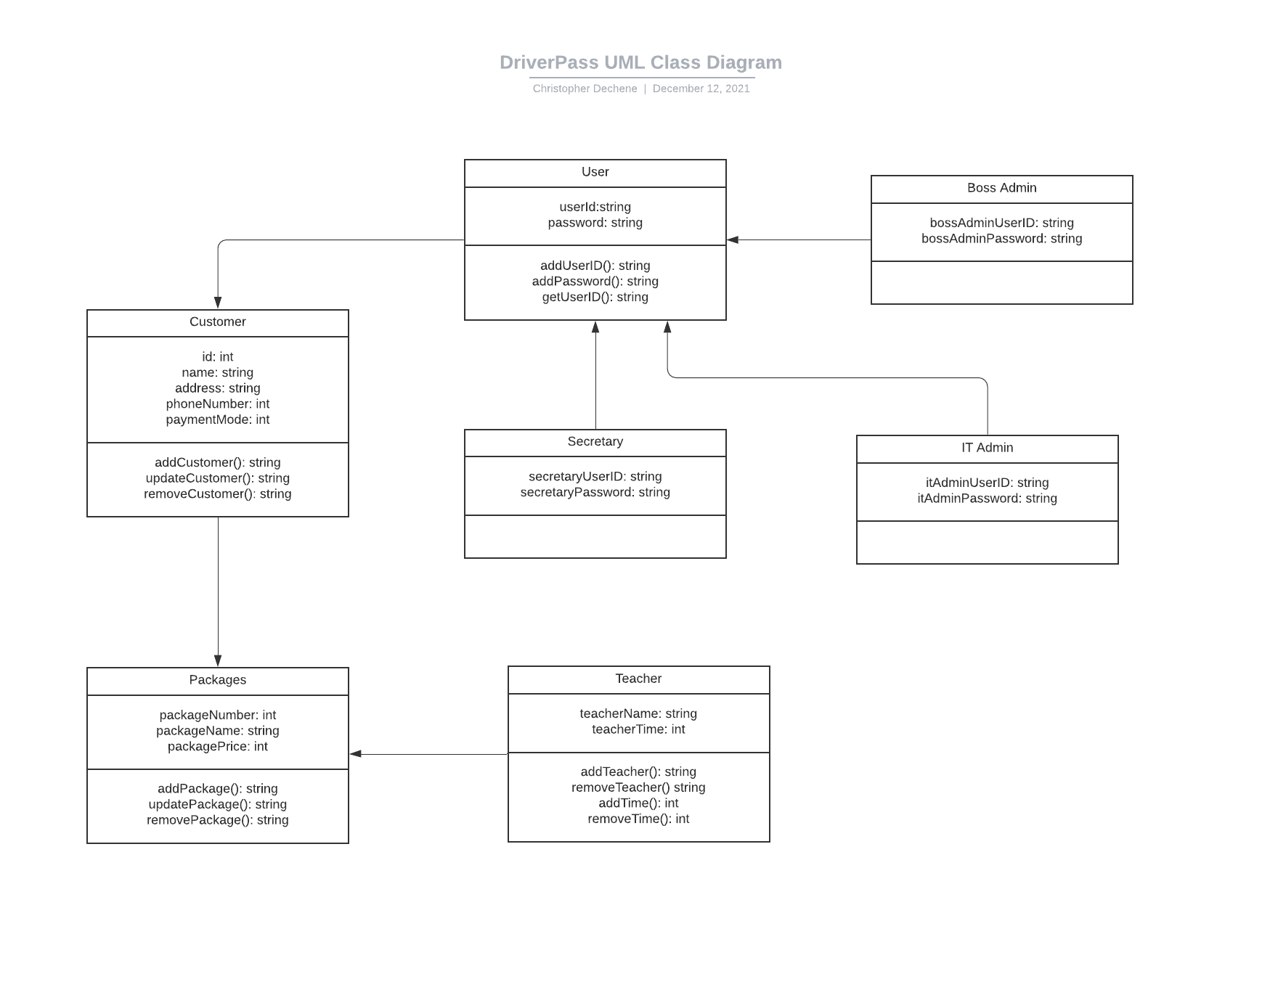

Technical Requirements
[Based on the diagrams you have created, describe the technical requirements of your system. These requirements should address the required hardware, software, tools, and infrastructure necessary for your system design.]

Hardware
- Up to date multi core CPU
- At least 8 GB of RAM
- At least 2 TB of hard drive storage
- Gigabit internet

Software
- Windows operating system for development
- iOS and Android devices compatibility
- Updated rules from DMV
- Cloud hosting server

